**Project 3**

**Integrate Grafana with Linux Server**

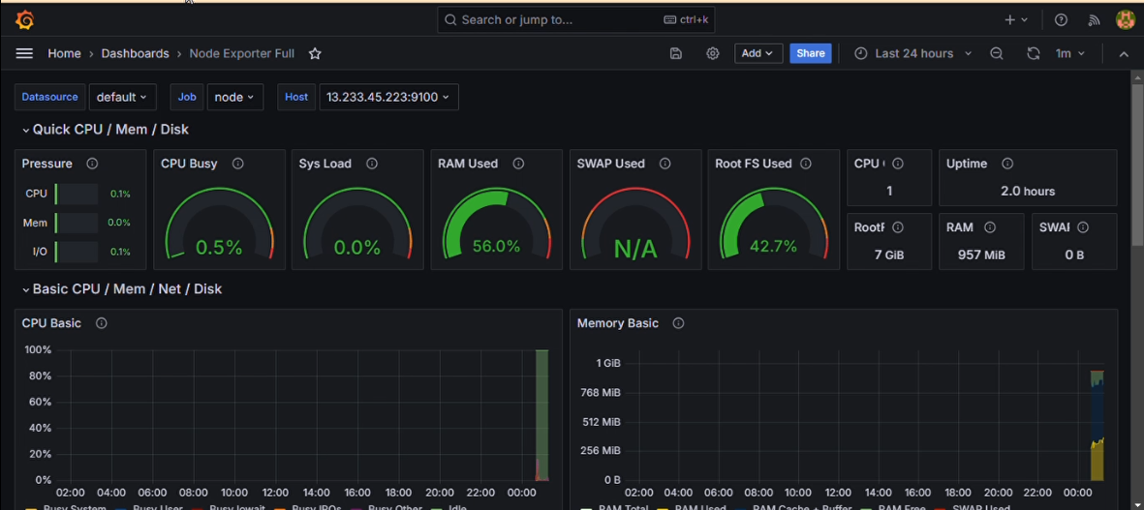

* **Step’s :- 1**
* Create a EC2 instance.
* Install Prometheus.
* Install node exporter.
* Install Grafana.
* View dashboard using stress.
* **Step’s :- 2**
* Login to AWS console and create a EC2 instance.
* Give instance name: Garfanaserver.
* Give select instance type Ubuntu Linux.
* Create key pair. Leave else as default.
* Create instance.
* Click on EC2 instance. Go to security and select security group.
* Edit inbound rule. Delete predefined rule.

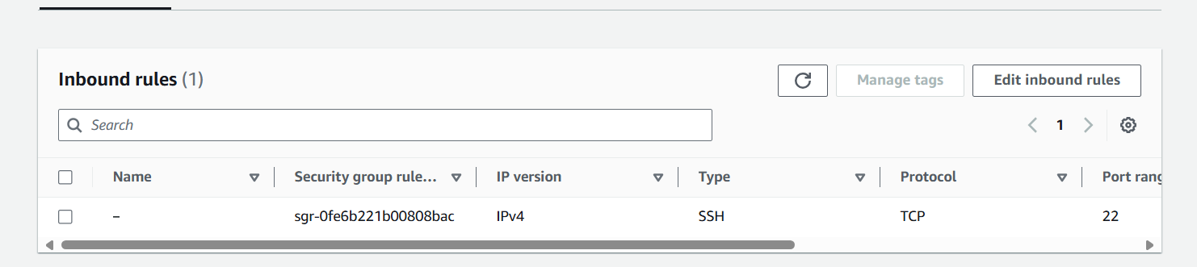

* Create a new rule
* Add a new rule and select Type- All traffic.
* And source- IPv4. Save changes.

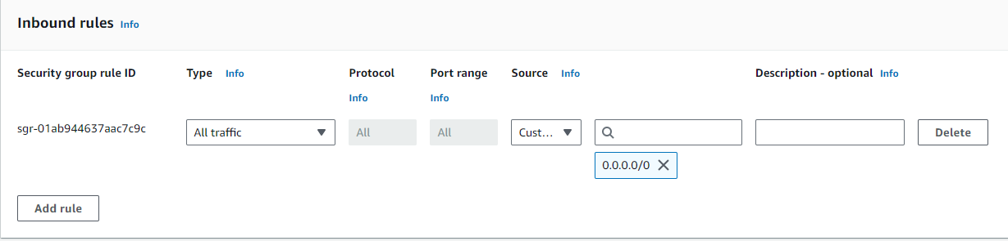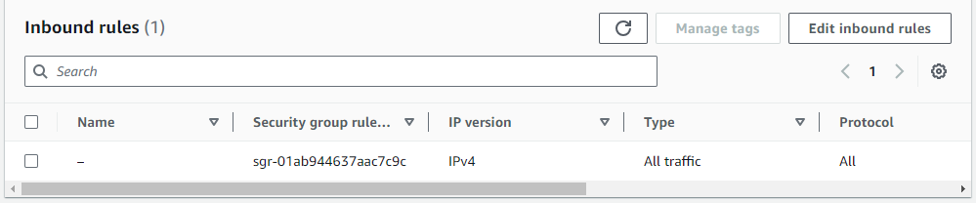

* Save else as default.
* Login to your instance in putty.
* Switch to root user using – sudo su.
* **Step’s :- 3**

*Install Prometheus*

* Install Prometheus using these commands.
  + wget <https://github.com/prometheus/prometheus/releases/download/v2.53.0/prometheus-2.53.0.linux-amd64.tar.gz>
* To view installation run “ls” command.
* Create file using this command.
  + tar xzf prometheus-2.53.0.linux-amd64.tar.gz
* Check file is created by ls command.
* Move the file using
  + mv prometheus-2.53.0.linux-amd64 /etc/Prometheus
* Run -

nano /etc/systemd/system/prometheus.service

* Enter this into file

[Unit]

Description=Prometheus

Wants=network-online.target

After=network-online.target

[Service]

ExecStart=/etc/prometheus/prometheus --config.file=/etc/prometheus/prometheus.yml

Restart=always

[Install]

WantedBy=multi-user.target

* Save it using crtl+O, press enter.
* Exit using Ctrl+X.
* Run this command.
* systemctl daemon-reload
* systemctl restart prometheus
* systemctl enable prometheus
* Check status using
* systemctl status prometheus
* Make sure the status is Active.
* Open the web UI using public IP with 9090 port.
* <http://intsanceip:9090>
* You will see a Prometheus UI.

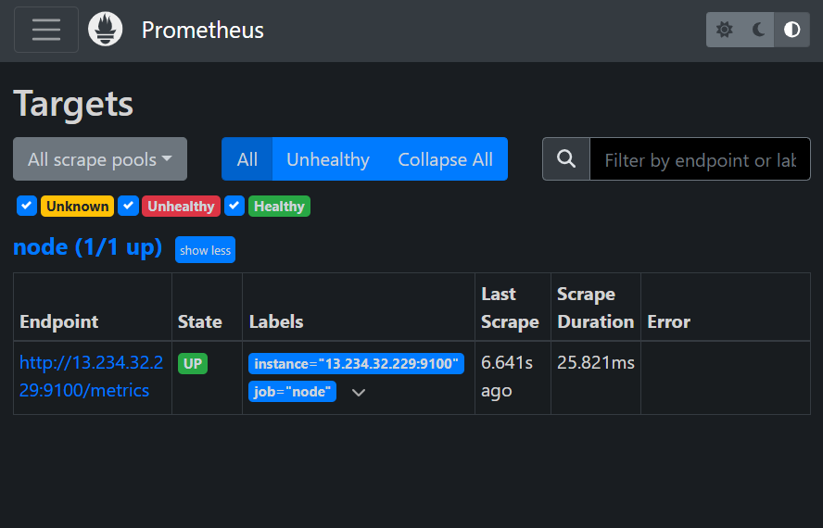

* Make sure the status is showing UP.
* **Step’s :- 4**

*Installing node exporter*

* Install node exporter using this command
* wget <https://github.com/prometheus/node_exporter/releases/download/v1.8.1/node_exporter-1.8.1.linux-amd64.tar.gz>
* Run these commands
* -ls
* tar xzf node_exporter-1.8.1.linux-amd64.tar.gz
* -ls
* mv node_exporter-1.8.1.linux-amd64 /etc/node_exporter
* nano etc/systemd/system/node_exporter.service
* mv node_exporter-1.8.1.linux-amd64 /etc/node_exporter
* nano etc/systemd/system/node_exporter.service
* Enter this in file

[Unit]

Description=Node Exporter

Wants=network-online.target

After=network-online.target

[Service]

ExecStart=/etc/node_exporter/node_exporter

Restart=always

[Install]

WantedBy=multi-user.target

* Restart and enable node exporter. Check status is active

systemctl daemon-reload

* systemctl restart node_exporter
* systemctl enable node_exporter
* systemctl status node_exporter
* Edit Prometheus scrap file using.
* rm -rf /etc/prometheus/prometheus.yml
* nano /etc/prometheus/prometheus.yml
* Enter this in file

global:

scrape_interval: 15s

scrape_configs:

- job_name: node

static_configs:

- targets: ['localhost:9100']

* Replace local host with your IP. Save and exit.
* check status is active.
* systemctl restart Prometheus
* systemctl status prometheus
* In Prometheus web Ui you see in target section 1 node with UP status.



*Install Grafana*

* Install Grafana using thise command.
* sudo apt-get install -y software-properties-common
* sudo add-apt-repository "deb https://packages.grafana.com/oss/deb stable main"
* sudo apt-get install -y gnupg2
* sudo apt-key adv --fetch-keys <https://packages.grafana.com/gpg.key>
* sudo apt update
* sudo apt install grafana
* Enable and check status.
* sudo systemctl start grafana-server
* sudo systemctl enable grafana-server
* systemctl status grafana-server
* Open Grafana web ui using ip address with 3000 port.

<http://instanceip:3000>



* You will see this window in web.
* Enter email-admin and password admin.
* Set new password.
* Click on menu in the top left corner.
* Go to connections and add new connections search prometheus data source.

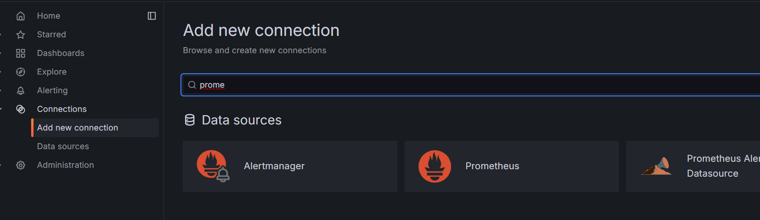

* Click the Prometheus section
* Paste your prometheus IP addersh in URL section.

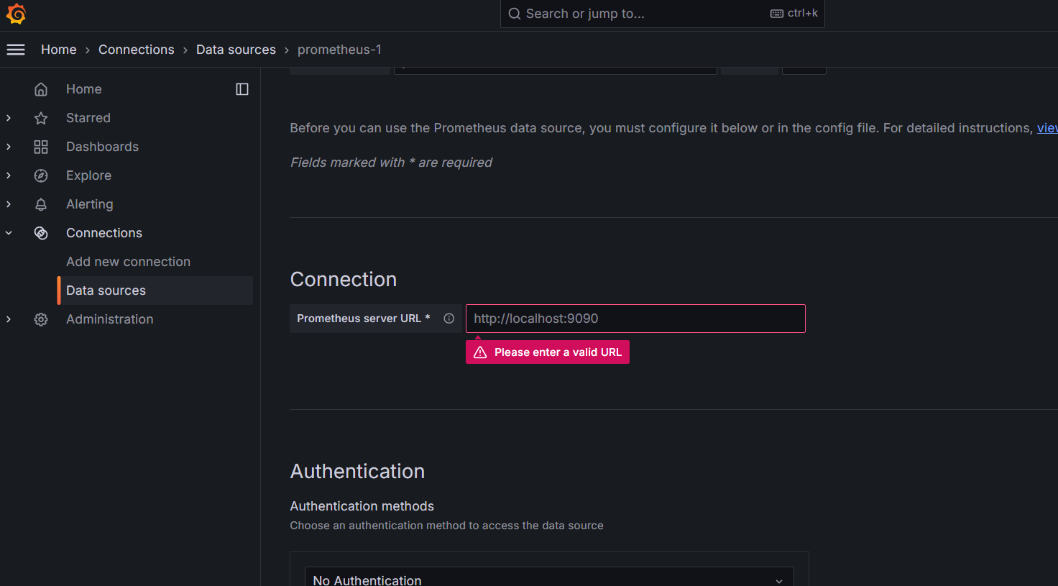

* Leave else as default and save it.
* Now go to dash board. Add new dashboard and enter the same as shown in the image

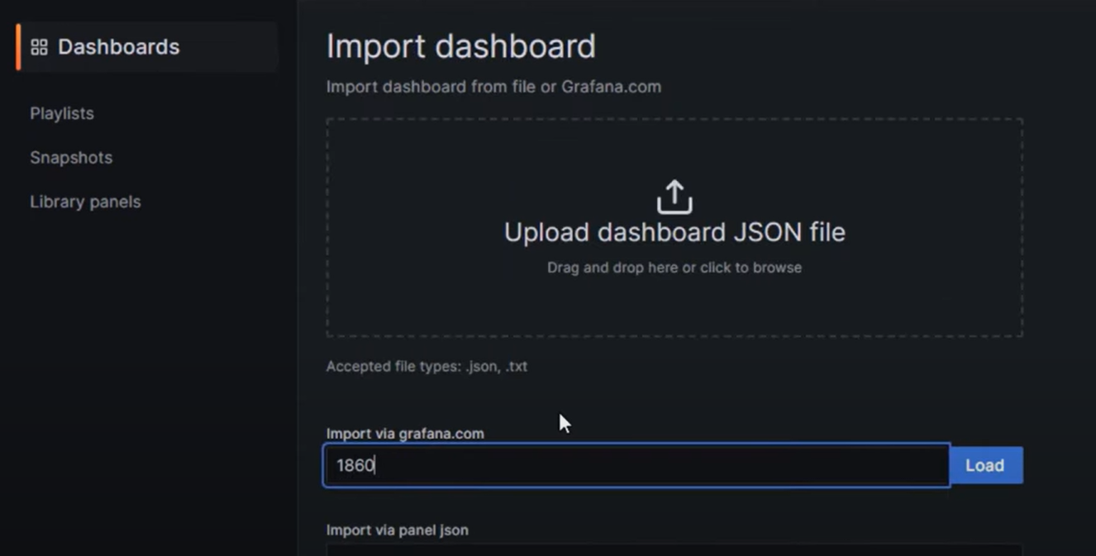

* You will see a new added dashboard.

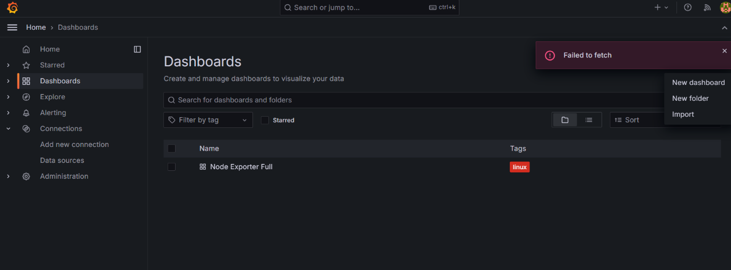

* Goto setting in links section add dashboard link.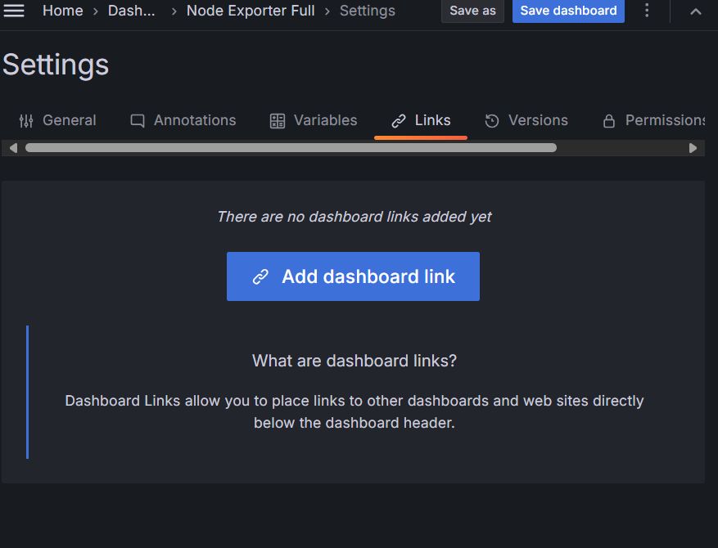
* You will see this dashboard.

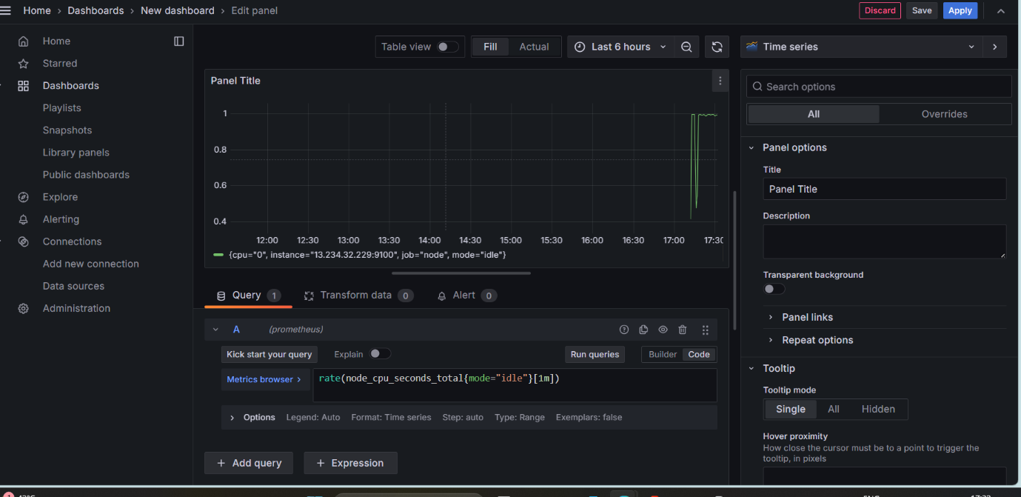

* In query section run this query as shown in image.
* In your linux instance run stress command
* sudo apt install stress
* stress --cpu 4 --timeout 300
* You can see graph in Grafana dashboard.

